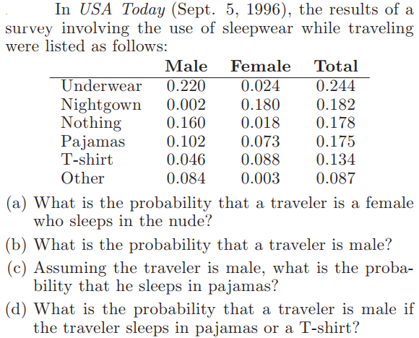
SOAL UTS STATISTIKA MATEMATIKA 1
- A

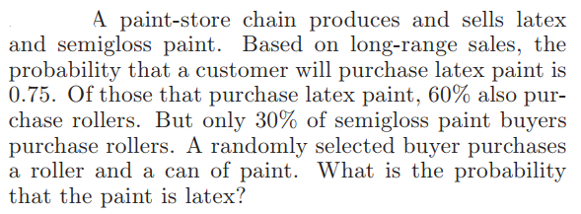
- A

- Suppose that the probabilities are 0.4, 0.3, 0.2, and 0.1, respectively, that 0, 1, 2, or 3 power failures will strike a certain subdivision in any given year.
- Show that the probabilities construct density probability function!
- Find mean and variance of that probabilities!

